21. CONSTRUCTION
21.1 Materials
The size, gradation, quantity, and desired properties of material used for the Dyke construction are given below.
21.1.1 Dyke
The Dyke cross section consists of accropode (armour layer), underlayer, rockfill, dredged sand, Riprap, rock layer, graded filter between rock fill and the dredged sand, and graded filter between dredged sand and riprap.
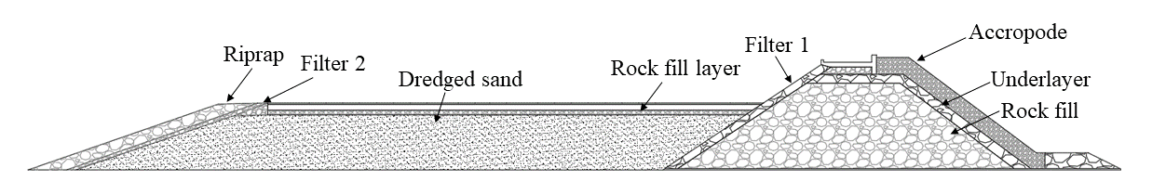Figure 22.1 Typical cross section of the dam

(a) Rockfill
Based on CWPRS report, the equivalent size of the rockfill is between 155 mm to 570 mm (corresponds to a weight between 10 to 500 kg) considering the specific gravity of the rock to be 2.7.
(b) Stones
Underlayer:
As per BS: 6349-part 7, the weight of the underlayer present below the accropode is between 1/7 to 1/15 of the weight of the individual accropode. Based on CWPRS report, the weight of the underlayer is fixed between 2 to 7 tonnes while the thickness of the underlayer is kept at 2.1 m for all the cross sections.
Riprap:
Considering the design of filter, recommended sizes of Riprap is between 50 mm to 250 mm to prevent the escape of filter material. A similar size range can also be used for the rock fill below the pavement.
(c) Dredged Sand
Well-graded sand (Cu = 15, Cc = 1.2) should be used as a dredged sand fill material considering strength and seepage point of view. The gradation of the dredged sand fill is given below. The gradation 1 (Figure 22.2) is fixed based on grab sample data taken from NIOT report.
Figure 22.2 Selected gradation 1 for dredged sand fill
(d) Filter media
Graded filter between rock fill and dredged backfill: (Filter 1)
The total thickness of the filter between the rock fill and dredged backfill is 3 m. The total thickness of the filter is divided into two layers i.e., 1 m thick layer (Gradation 2) closer to the backfill and 2 m thick layer (Gradation 3) closer to the rock fill to provide a proper gradation between the larger sized rocks and sand. Filters are designed considering fines present in the dredged sand fill. There will be an upper and lower limit for the filter gradation (based on USDA NRCS design criteria) designed with respect to base soil. The chosen gradation 2 is close to the upper limit of the filter band which will prevent the removal of fines from the dredged sand fill.
Table 22.1 Gradation 2 | Table 22.2 Gradation 3
  Sieve (mm) | Percentage passing | Selected percentage passing
  80 | 100 | 100
  63 | 99-100 | 100
  16 | 88-100 | 93
  4.75 | 70-100 | 73
  2.36 | 61-100 | 65
  1.18 | 40-77 | 45
  0.6 | 21-62 | 25
  0.3 | 3-37 | 8
  0.15 | 0-20 | 1
  0.075 | 0-5 | 0
  Sieve (mm) | Percentage passing | Selected percentage passing
  80 | 100 | 100
  63 | 96-100 | 97
  50 | 90-100 | 91
  40 | 82-100 | 85
  25 | 67-92 | 70
  20 | 62-85 | 65
  16 | 50-79 | 55
  4.75 | 0-5 | 5

Graded filter between Riprap and dredged backfill: (Filter 2)
The total thickness of the filter between the riprap and dredged backfill is 2 m. The total thickness of the filter is divided into two layers i.e., 1 m thick layer (Gradation 2) closer to the dredged backfill and 1 m thick layer (Gradation 3) between the riprap and gradation 2.
(e) Accropode
The accropode blocks come in standard sizes and weights. The thickness of the armour layer is 3.28 m for all the cross sections.
(f) Stone Columns
Ground improvement methodology using Stone Columns (Area replacement ratio = 0.25) adopted in the intertidal region having very soft clay.

21.2 Equipment
21.2.1 Vibro-compaction
21.2.2 Stirrer
21.3 Method
21.3.1 Methodology of improving the foundation soils in Intertidal regions
As discussed in sections 3. a and 3. d, the depth of problematic soil ranges with a depth of 6 m to 10.5 m in the intertidal region at Bhavnagar and 3 m to 6 m in the intertidal region at Dahej from the seabed. Of all the options of ground improvement discussed in section 2. a, stage-wise construction with stone columns (i.e.,11 m in the intertidal region at Bhavnagar and 6.5 m in intertidal region at Dahej) appears to be the optimum solution. As top layers in this region may not permit the trafficability of the equipment for improving the ground, shallow stabilization may have to be done prior to the construction of a working platform over it. The following methodology may be adopted in the construction of the foundations in intertidal regions.
(1) Shallow stabilization
The operation of shallow stabilization may start at the place where the soil is competent enough (definitely not soft clays) to bear the equipment for cement stabilization. The objective of this stabilization process is only to support the equipment that install stone columns. Mass stabilization or column stabilization may be done to achieve this objective. Depending on the chemical nature of the top clay layers, the depth of the clay layer that needs to be stabilized and the type and amount of cement to be used may be decided by the concerned agency. The execution machine of the stabilization should have enough length to mix the cement in front of it to a maximum distance and to the desired depth (see Figure 5.1).
Table 5.4 Problematic soils in corresponding boreholes in the intertidal region at Bhavnagar region given by COMACOE.
S. no. | BH no. | Type of soil | Thickness | Method of treatment
1 | T1 | Soft clay | 9 m | Stone Columns
2 | T2 | Soft clay | 12 m | Stone Columns
3 | T3 | Soft clay | 10.5 m | Stone Columns
4 | T9 | Soft clay | 4.5 m | Stone Columns
5 | SPT 2 | Soft clay | 6 m | Stone Columns
6 | T7 | Soft clay | 3.5 m | Stone Columns
7 | T8 | Soft clay | 4.5 m | Stone Columns
8 | T9 | Soft clay | 4.5 m | Stone Columns
9 | SPT 3 | Loose sand | 0 - 4.5 | Stone Columns
9 | SPT 3 | Soft to firm clay | 4.5 – 7.5 | Stone Columns

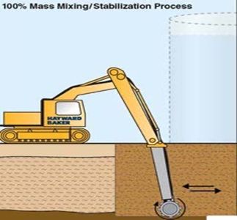
Figure 5.1 Mass mixing stabilization (Courtesy of ©Hayward Baker Inc)
The blending of the soil mass may be achieved by either use of an excavator-mounted mixing tool with unique shuttles pneumatically delivering the binder to the head of the mixing tool and into the mixed zone or by self-injection of binder into a rotating auger or mixing head and the soil. The mixer rotates and simultaneously moves vertically and horizontally while mixing the soil block.
(2) Working Platform
Prior to the initial set of the stabilized mass, a geo-membrane may be placed on top of stabilized soil on which a selected granular material (such as baby chips, gravel, etc.,) that will not get washed out during high tides. These fill materials compress the freshly stabilized mass forcing out all air pockets that may have formed during mixing (Hayward Baker Inc; Massarsch and Topolnicki, 2005; EuroSoilStab, 2002). The granular mat over the geo-membrane should be of sufficient thickness such that it surpasses the high tide level by at least 30 cm, so that construction activity may not be disturbed by tides. The coarse mat and the geo-membrane are selected such that the penetration of the mandrel while installing stone columns should not be disturbed. The design of type and thickness of granular mat and geo-membrane may be performed by the concerned agency. The stabilization process and construction of the working platform may be done in a step-wise fashion, say a 10 m stretch, starting from the starting point of the intertidal region or at the place where competent topsoil is available.
(3) Installation of Stone columns and stage-wise construction/loading
After the construction of the working platform up to a level of 30 cm above the high tide level, Stone columns are installed up to a depth of 0.5 m beyond the soft clay layer using the installation rigs. The proposed ground improvement for the soft clays in this project is stage-wise construction along with Stone columns. The design of spacing, time for consolidation, heights of rockfill/embankment to be placed to achieve a 90% consolidation may be carried out.
The rig is positioned at the drain location and then place on the anchor on the drain end. Penetrate mandrel to a depth of 0.5 m beyond the depth of the soft clay layer and withdraw it. Installed stone columns are cut above the drainage material.
The working platform of 0.3 m above the High tide level over the stabilized soft clays acts as an initial surcharge for the overlying soft clays. Thereafter the designed thickness of rockfill is placed and allows the soft clay to reach 90% of consolidation and proceed further.
(4) Sequence of foundation construction for the breakwater in intertidal regions
- Consider a 10 m stretch starting from a land whose ground level is above the high tide level.
- Stabilize the top 1 m layer of soft clay for the considered stretch.
- Prior to the initial set of the stabilized mass, a geo-membrane has to be placed on top of stabilized soil.
- Place the coarser material on the geomembrane up to a level of 30 cm above the high tide level.
- Continue steps 2, 3, and 4 till the end of the intertidal region or beginning of the gulf region.
- Simultaneously, install Stone columns through the working platform up to a depth of 0.5 m beyond the bottom of the soft clay layer.
- Allow the soft clay layers to consolidate under working platform fill.
- Place the calculated thickness of breakwater material (rockfill) over the working platform and allow the soft clay layers to consolidate to a 90% consolidation.
- Continue the stage-wise construction of the breakwater at a place.
- Continue steps 6, 7, 8, and 9 till the end of the intertidal region.
The sequence of construction of the foundation for the breakwater in intertidal regions is shown in Figure 5.2.
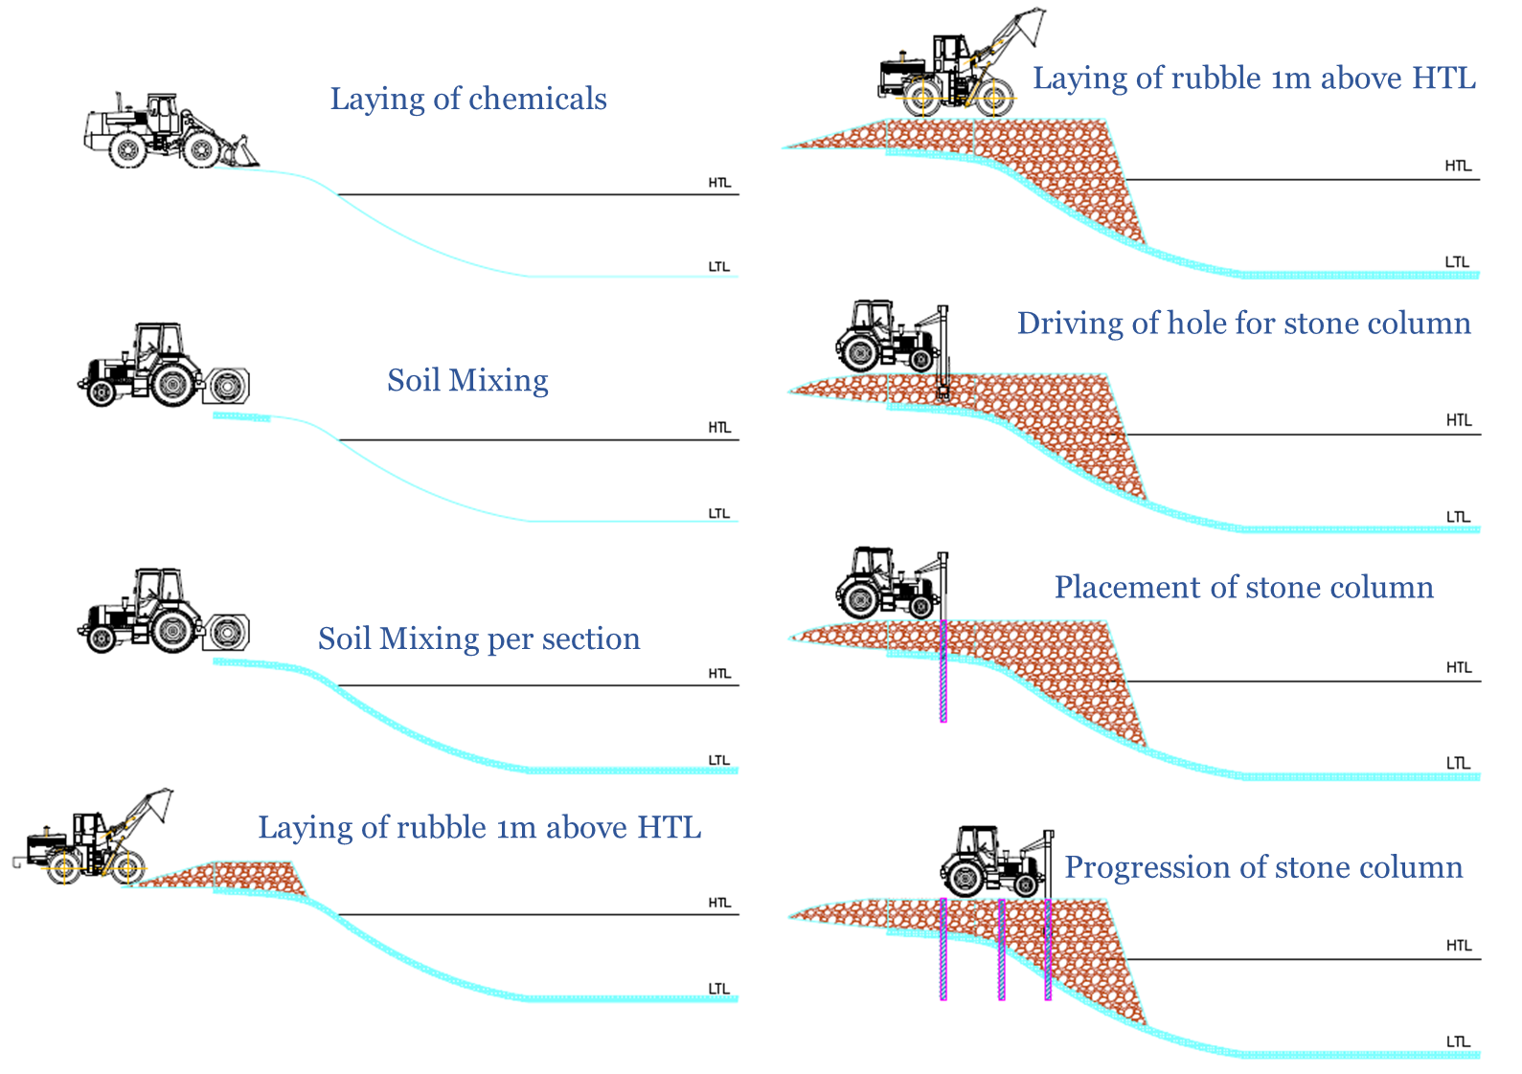
Figure 3.2 Sequence of construction in intertidal region

21.3.2. Construction methodology of foundation in the Gulf region
From liquefaction analysis, the top 1-6 m of soil is found to be potentially liquefiable, as shown in liquefaction results (Table 15.13). Hence, the ground improvement by vibro-compaction is proposed for the top 6 m, and an improved value is adopted for the modulus is considered for the present analysis. Loose silty sands are to be compacted using deep Vibro compactors. After compacting loose sand layers, a Polypropylene mattress is laid on top of it using barges over which 150 mm to 200 mm of quarry size stones are placed. This works as a floor protector and prevents the seabed from erosion. Rockfill is placed over the floor protector forming a breakwater portion. The sequence of construction is shown in Fig. XXX.

Table 15.13 Potentially liquefiable layers in gulf region
Borehole no. | PGA = 0.225 g | PGA = 0.36 g
GT-SPT4 | 1-9 m, 15-20 m | 1-12 m, 15-20 m
GT-SPT5 | 1-9 m, 12-20 m | 1-9 m, 12-20 m
GT-SPT6 | 1-6 m | 1-6 m
GT-SPT7 | 1-6 m, 9-18 m | 1-20 m

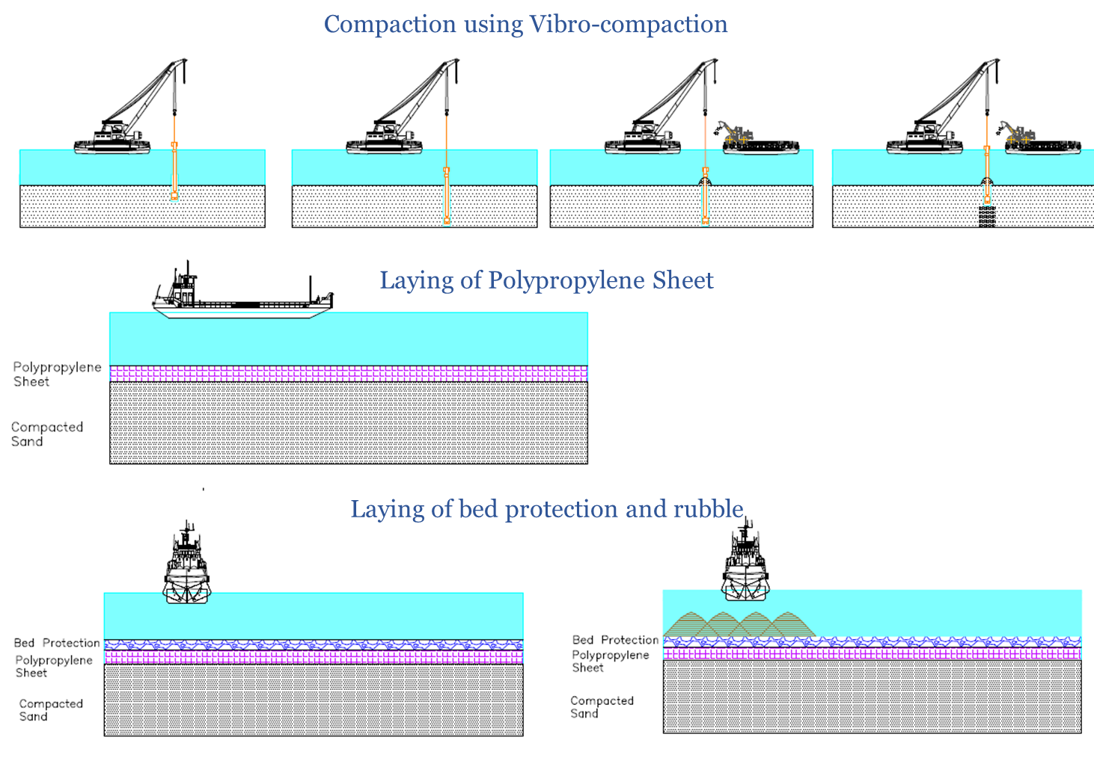
Fig XXX. Sequence of ground improvement in Gulf region
(1) Typical cross-section of the dam
The cross-section of the dam has four major components i.e., breakwater on the seaside, dredged sand fill embankment on the reservoir side, inverse rock filter, and floor protector. The purpose of the breakwater is to nullify the wave action and to provide suitable tranquillity for the construction of dredged sand fill embankment. The purpose of the dredged sand fill embankment is to carry a tentative 10 lane road and a railway line on its top width and also to hold the fresh water in the reservoir.
A cross section as per our design team is shown in Figure 5.3.
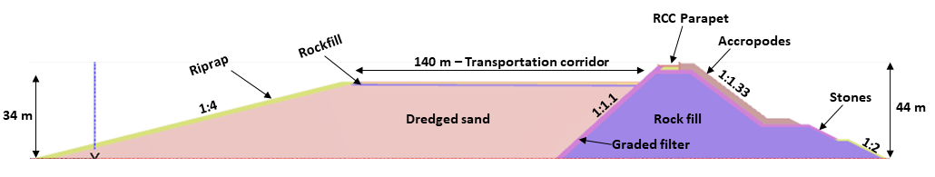
Figure 5.3 Cross-section of Kalpasar dam for a seabed level of RL – 25 m (by IIT Team)

5.5 Breakwater
5.5.1 Components of Breakwater
Core -The purpose of the core is to prevent wave transmission into the other side of the dam; hence the core material shall be quarry rock and well graded. The core material should not be washed out through the armour layers. According to CWPRS design, the core material shall consist of 10 to 500 kg well-graded quarry run. Gradation of the core will be estimated based on the filter criteria.
Toe -The Toe functions as the foundation for the armour layer. It also may catch armour units displaced from the armour layer; The Toe is normally constructed of large stones of quarry run or the secondary layer itself is extended to form the toe mound.
Filter layer -The objective of the filter layer (underlayer) is to prevent the core material from being washed out through the armour layer and also to act as a filter between the core and armour layer. This layer provides a stable bed for the armour layer and also dissipates wave energy passing through the armour layer.
Armour layer -The purpose of the armour layer is to protect the core from direct wave action through the dissipation of wave energy. Armour layers are built of large rocks or larger concrete armour units. AccropodeTM II units are finalized as armour units since they are recommended by the Kalpasar department to CWPRS.
Rear rock armour is designed based on the permissible wave overtopping and non-breaking waves propagating into the harbour.
Superstructure -The superstructure is used either to reduce the crest elevation or to reduce wave overtopping or as a roadway for traffic or pipelines. The superstructure is usually constructed of concrete.
5.5.2 Types of construction and corresponding equipment
Based on the site-specific conditions, land-based construction or water-borne construction, or a combination of both may be chosen. The choice of equipment is based on the distinction between direct dumping of bulk material, (in case of core), and controlled placement (individual pieces of armour stone, such as in armour layers and underlayers of slope and/or bed protection works) which is shown ion Figure 5.10. Controlled placement involves dumping of limited quantities per cycle or placement of individual stones.
Land-based construction
Dumping of bulk material
Direct dumping (bulk) of the material can be done using trucks or loaders, hydraulic excavators, or wire-rope cranes. The type of equipment required depends on the size of the job and the working conditions on-site.
Controlled placement
Controlled placement may be defined here either as bulk armour stone placement in relatively small quantities per cycle or as the individual placement of heavier pieces of armour stone. A hydraulic excavator and wire-rope crane may be used for this operation. Employment of these equipment depends mainly on their capacity of placing from the working platform.
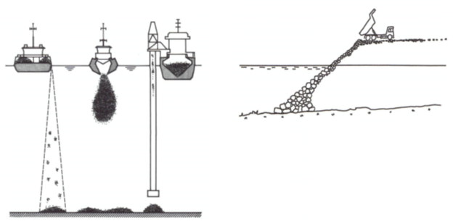
Figure 5.4 Bulk rock dumping by side dumping vessel, split barge and fall pipe, and Land-based dumper (Rouault et al., 2005)

Sea-borne construction
Dumping of bulk material
Split-hopper barges, flat-top barges with wheel loader, crane barges equipped with rock trays/skips and side stone-dumping vessels, or side-unloading barges are generally opted for this type. The mechanism of dumping using a flat top barge and side stone dumping vessels is shown in Figure 5.11.
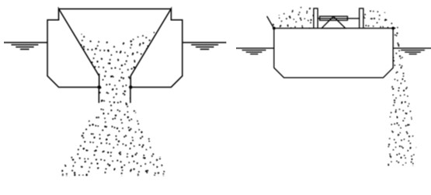
Figure 5.5 Mechanism of dumping in Flat top barge and Side Stone-dumping vessel (Rouault et al., 2005)

Controlled placement
Side stone-dumping vessel or barge, flat-top barges with a wheel loader or excavator, Pontoon or vessel with a wire-rope crane, Fall-pipe vessels are different types of equipment used for controlled placement in seaborne construction.
21.4 Sequence of Construction
21.4.1. Dyke
The information regarding the detailed construction methodology and equipment to be adopted are given in CIRIA C683 and BS 6349-7. The final methodology to be adopted for the current project should be in line with the codes CIRIA C683 and BS 6349-7. The important phases of the construction of rubble mound breakwater are
- Placement of mattresses on the bottom (if needed).
- Placement of core fill.
- Placement of core structures.
- Placement of sublayers.
- Placement of armor layers.
- Placement of crown slabs and wave screen.
- Placement of shoulders.
- Completion and adjustment of armor.
The typical plan of different methods of construction is discussed in the following section.
A typical plan of a land-based operation (CIRIA C683).
- Placing of quarry run core by dump trucks.
- Placing remainder of the core by crawler crane and/or excavator.
- Placing scour protection with a crawler crane.
- Placing of underlayer by crawler crane or excavator.
- Placing of the toe on the seaward slope by crane or excavator.
- Placing of armour layer on the seaward slope by crane or excavator.
A typical plan of a waterborne operation (CIRIA C683).
- Placing scour protection, from side stone-dumping vessels.
- Placing of quarry run core from split-hopper barge (up to 3 m below water level), then tipping with wheel loader from a flat-top barge or by a floating crane.
- Trimming of slopes and placing of underlayer by floating hydraulic excavator and/or floating crane.
- Placing of the toe on the seaward slope by side stone-dumping vessel or floating crane.
- Placing of armour layer slope by a floating crane.
Combination of both the methods
- Placement of core by dump barge.
- Placement of the upper core by rear dump trucks.
- Adjustments of the slopes by crawler crane.
- Placement of the second sublayer on the core
- Placement of the toe, most likely by a dump barge.
- Placement of the first sublayer by crawler crane.
- Placement of the armour rock or armour blocks by crawler crane.
- Casting of the crown slab.
- Completion of armour protection of inner section (rear armour).
However, the type of method to be adopted for the breakwater part of the Kalpasar dam is entirely site-specific and depends on the availability of the equipment. The knowledge in this sector is limited to the authors of this document. It is highly recommended to collaborate with specialist contractors. The design will be modified further after taking their inputs and suggestions.
5.6 Sand fill Embankment
The main construction material for sand fill embankment is the sand from the seabed itself. As the length of the dam to be built is nearly of length 48.5 km with a typical width of 300 m, constructing the embankment with borrowed material from the land would be too expensive. The seabed of the gulf is Silty Sand up to a depth of a minimum of 40 m. So, it may be economical to dredge the suitable soil from the gulf itself and fill it followed by deep Vibro compaction.
Types of dredging
Three main techniques commonly used in the dredging industry are trailing suction hopper dredging (TSHD), cutter suction dredging (CSD), and mechanical dredging (grab or backhoe dredger).

Selection of areas to be dredged
National Institute of Ocean Technology (NIOT) conducted grab sampling (63 samples) (see Figure 5.12) and Vibrocore sampling (43 samples) in the dam corridor area in 2013. It conducted laboratory tests on those 106 samples and provided soil classification. The requirements of the sand fill to be filled in the embankment has to be established using their results. Based on the soil information provided by NIOT from grab samples and Vibrocore samples, the area and depth up to which it has to be dredged should be decided. Detailed information about the testing and other details can be found from the report titled “Geophysical survey for revised dam corridor” dated 11-.01-2013.

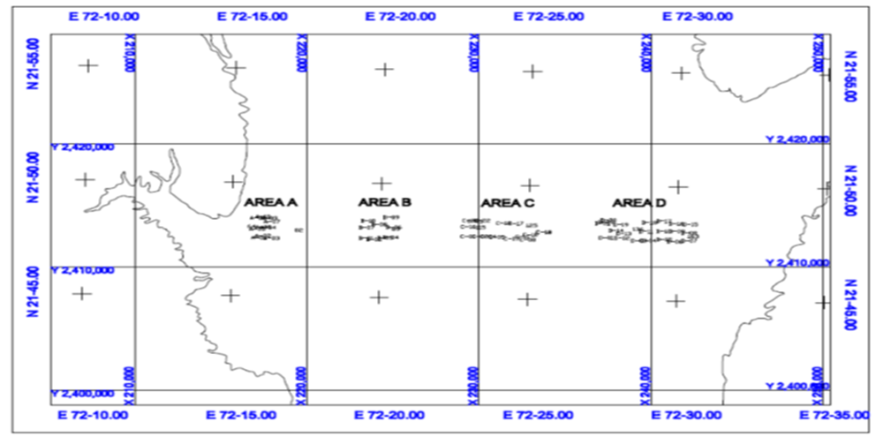
Figure 5.6 Location of grab sampling points in the proposed dam corridor by NIOT in 2013
Methodology of dredging
Dredging is a highly specialized job that requires expertise in that field. IIT Madras group has recommended forming an expert group especially a dredging expert (example: Dredging Corporation of India) to be a part. The detailed methodology for dredging has to be finalized based on the availability of the equipment with the contractor, specific site conditions, and requirements. This may be done after forming allies with the dredging contractor. However, the dredging method should be in line with the Hydraulic manual by CIRIA.

Components of the sand fill embankment
The major components that form the sand fill embankment of the Kalpasar Dam are sand fill, rock toe, and floor protector that continues beyond the dam on either side.
Construction methodology of sand fill embankment
As the construction of sand fill embankment should be done in the water, it may be difficult to achieve a slope of 1V:2H. The hydraulic placement of the sand fill yields a flatter slope than 1:2. So either the embankment should be built wider than the designed width and dredge it off the extra width to attain the required slope or the sand fill embankment should be supported by a rock toe or geotextile tube bunds at the reservoir side to attain a 1:2 slope.
The dredged sand from the seabed should be filled in the position and compact to achieve the required design density after laying the support at the toe. Again, the knowledge and the experience of this team are limited, so an expert group which is specialized in the construction of similar projects should be allied with the current team. The final construction methodology will then be finalized after taking their inputs on-field difficulties and feasibilities.
5.7 Inverse rock filter
A designed inverse rock filter needs to be constructed between rock fill and dredged sand embankment. The functions of this filter are to protect the sand content in the embankment and also not to allow the escape of it into rock fill and thereby into the sea. These layers are to be placed after completing the breakwater. The thickness of these layers and the sizes of the rock to be employed are dependent on the design. However, the construction method of placement of these layers needs to be decided after forming the expert group and taking the inputs from them.
5.8 Floor protector
To prevent the seabed from erosion and increase the lateral stability of the dam, a floor protector needs to be constructed after improving the ground. A polypropylene mattress can be laid on the top of the compacted soil over which 200 mm thickness of quarry stone can be placed.
5.9 Closure of the breakwater
Utmost importance has to be given to the design and execution of the final closure of the breakwater. Studies on closing sequences and construction periods, optimal weight and quantity of dumping rocks, sea bed scouring, stability of the bottom protection, etc. are to be conducted. As the gap of the closure reduces, the velocities of the currents increase. To withstand those velocities heavier sizes of rock are needed. Similar to that of the Saemangeum sea dike in South Korea, rock-filled gabions can be opted for. Floor protection in this area needs to be designed specifically. The method of closing the gap depends on the availability of the equipment and the method of construction opted.
Again, the construction methodology of this part also needs expert group recommendations.

